Part 1

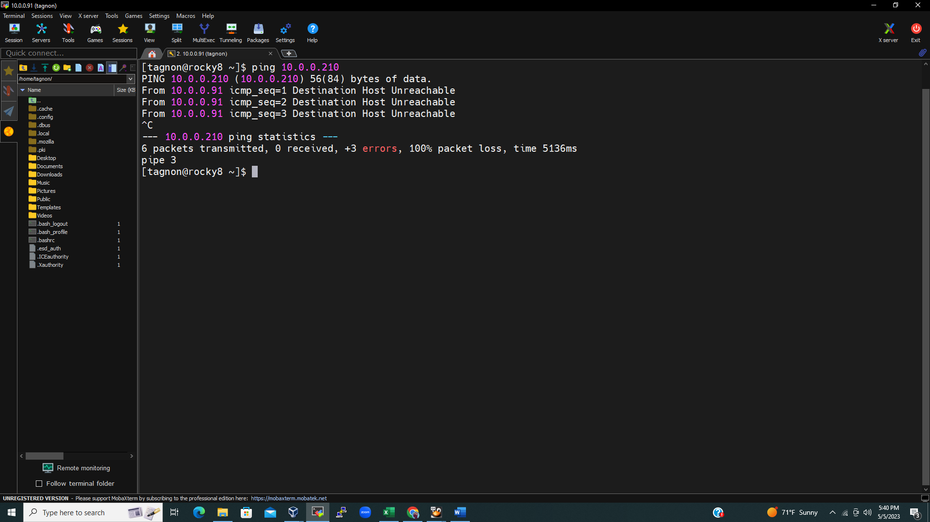

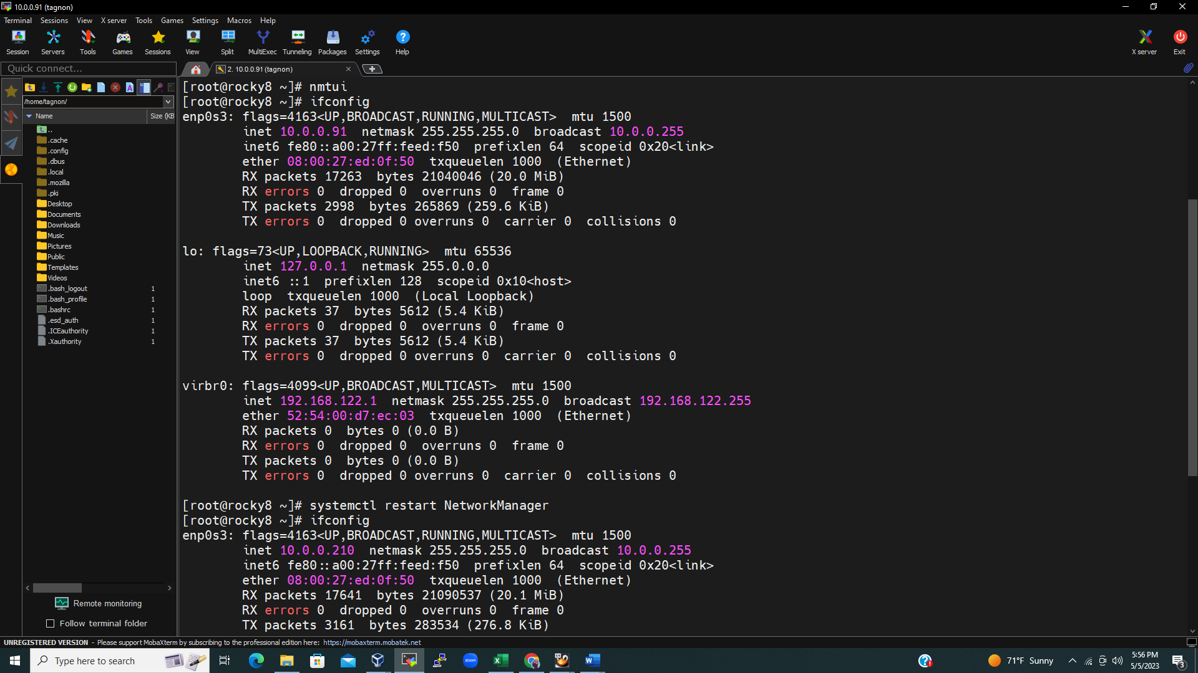

1-

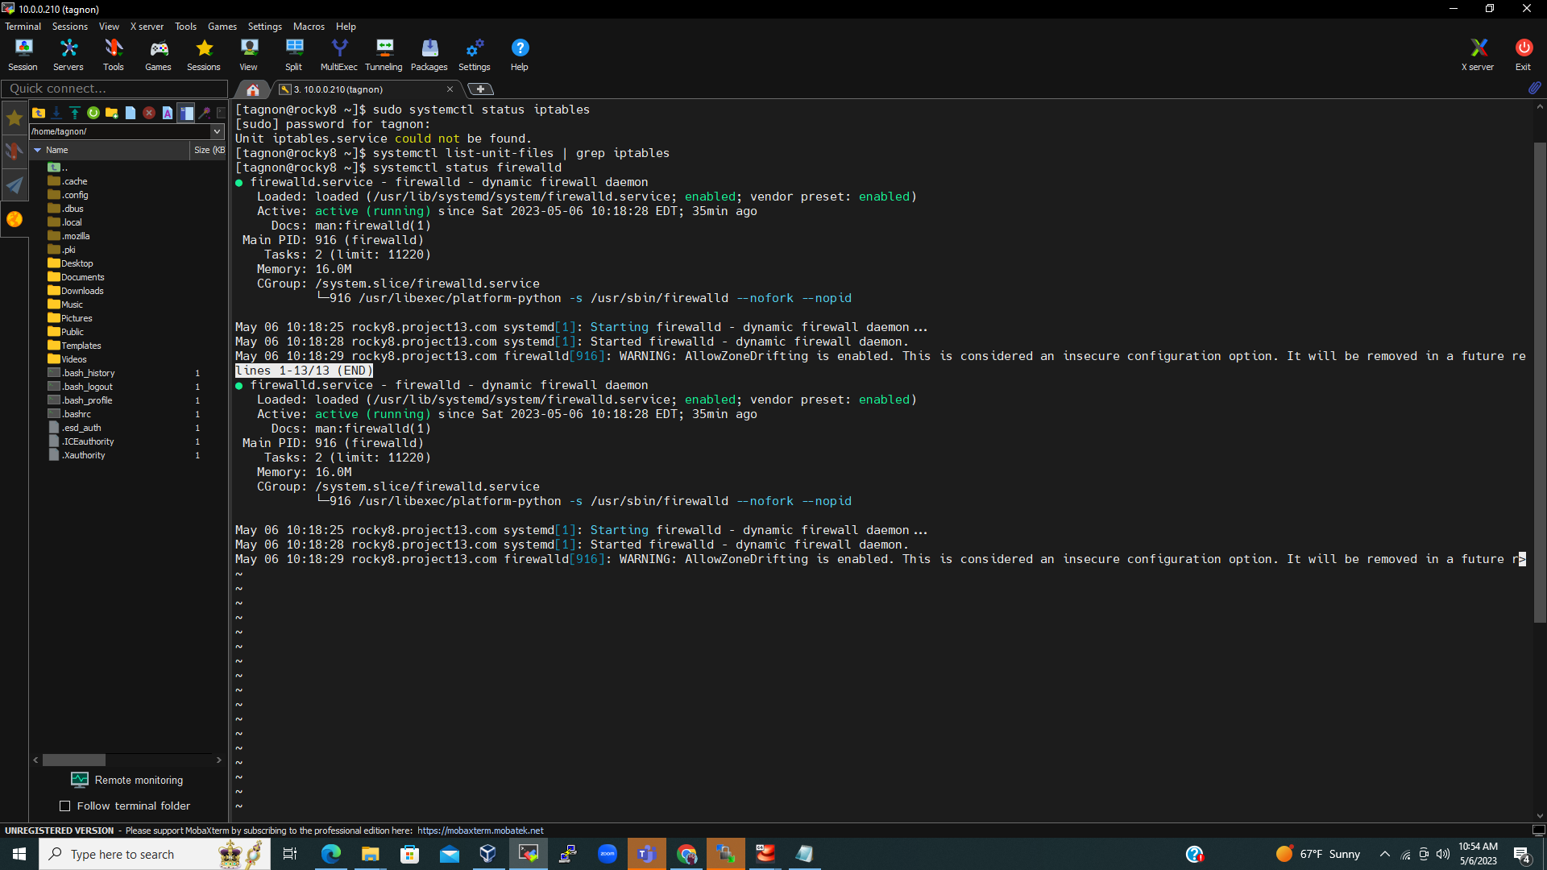

2-

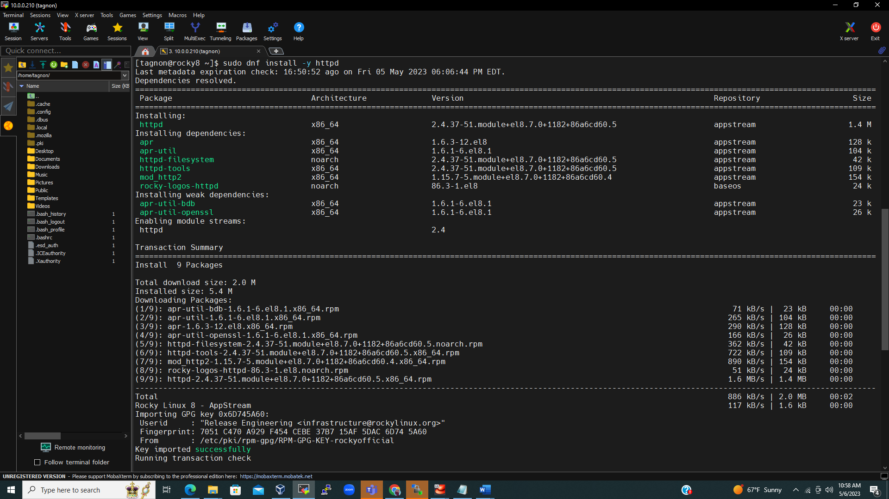

3-

4-

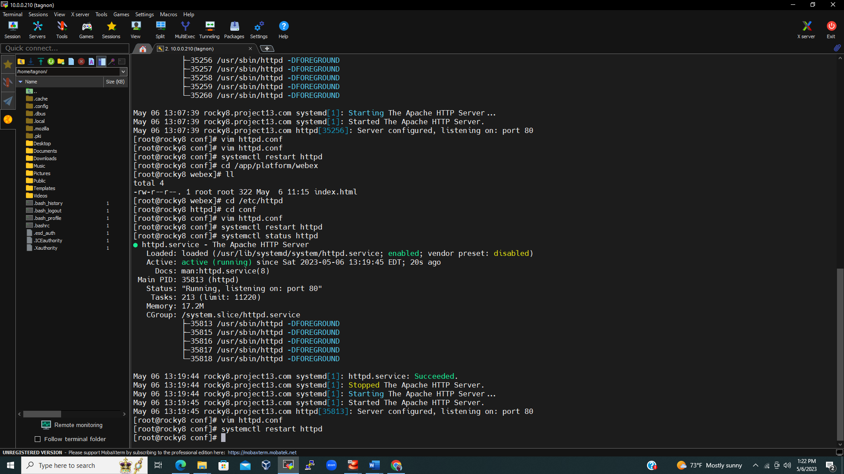

Part 2

1-2-3

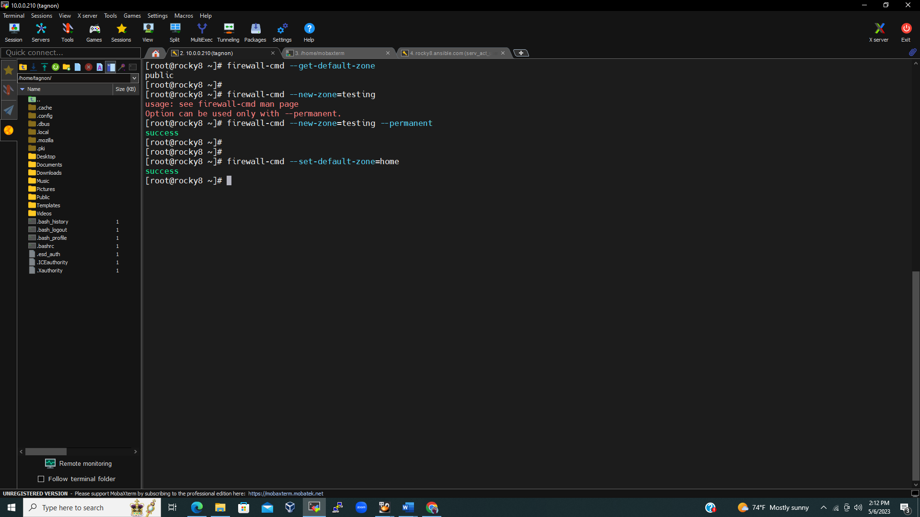

4-

5-6

7-

8-

9-10

11-12-13

Part 4:

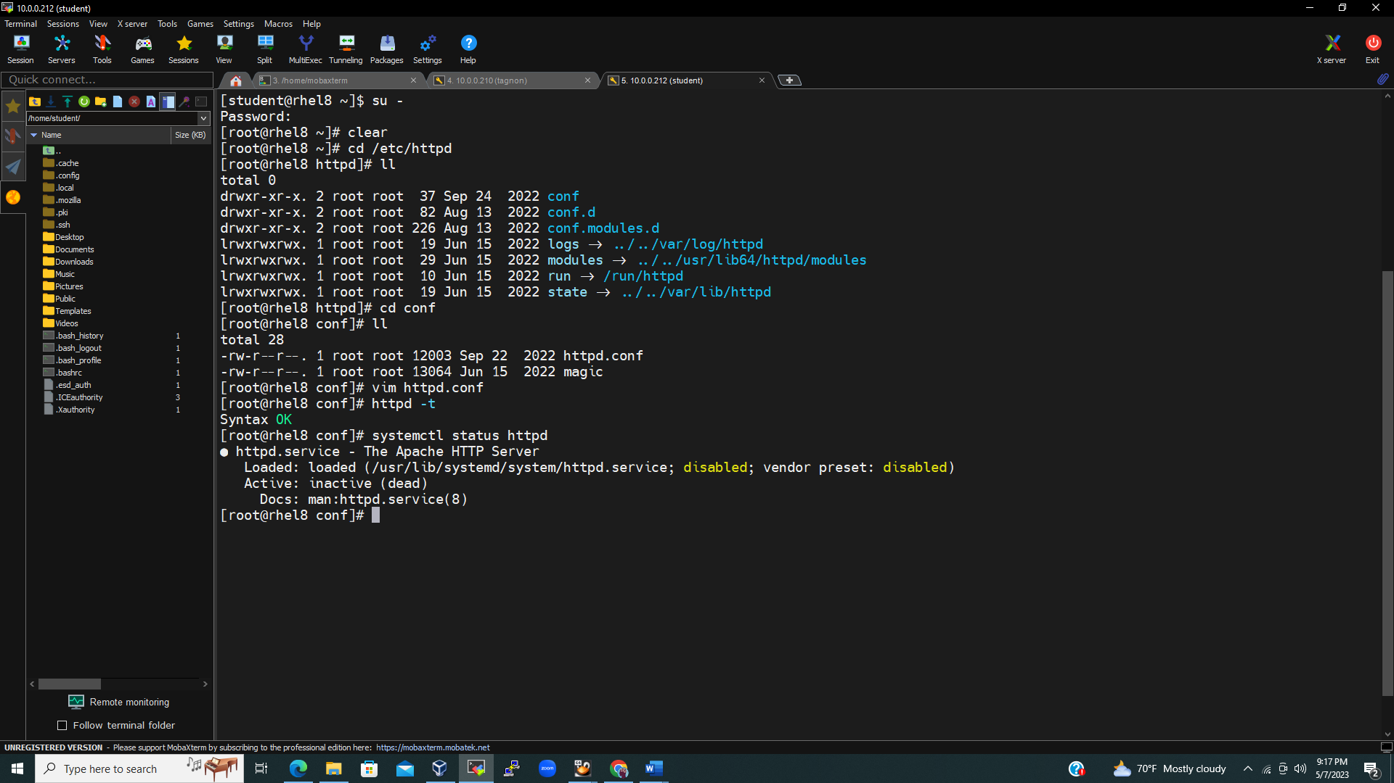

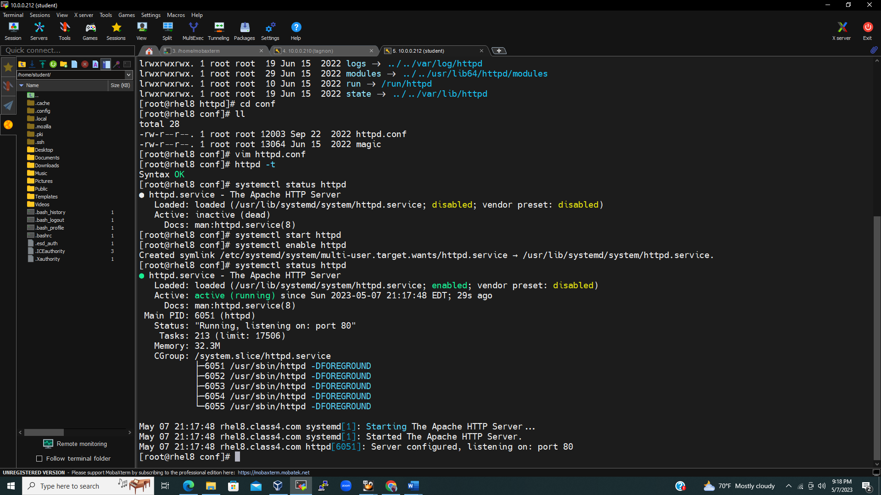

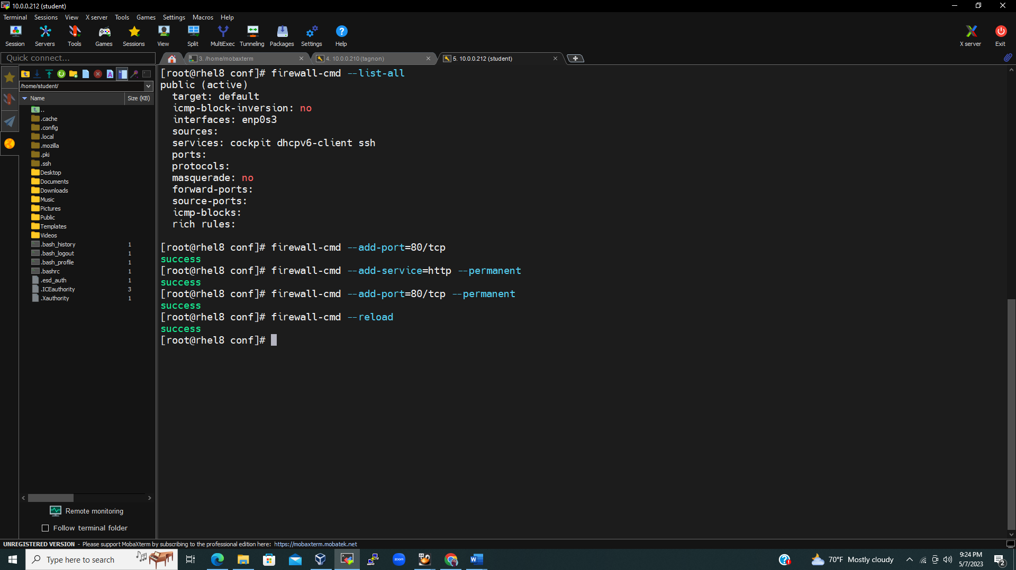

Part 3: